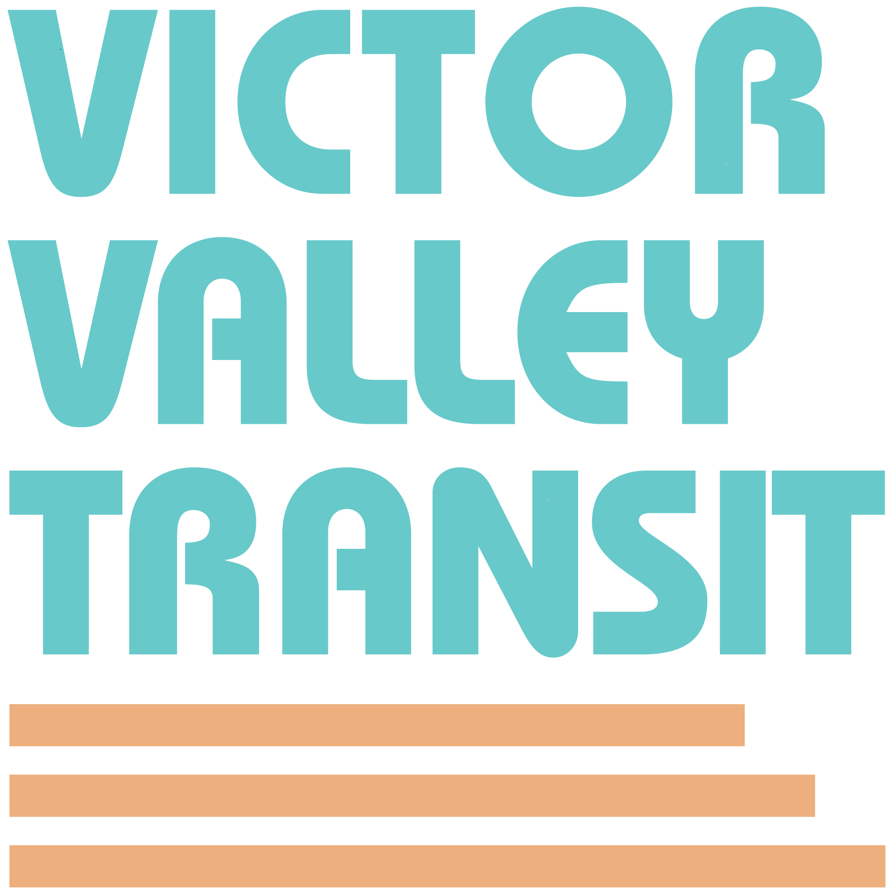

Victor Valley Transit Authority

CANCELED MEETING NOTICE

The Victor Valley Transit Authority Board of Directors meeting scheduled for December 15, 2025, at 9:30 am at Victor Valley Transit Authority has been cancelled.

The next meeting will take place on
Tuesday, January 20, 2026, at
Victor Valley Transit Authority,
17150 Smoke Tree Street, Hesperia, Ca 92345

