SOCIAL MEDIA BEST PRACTICES

FY 2022 – 2023

Social Media Standards and Requirements

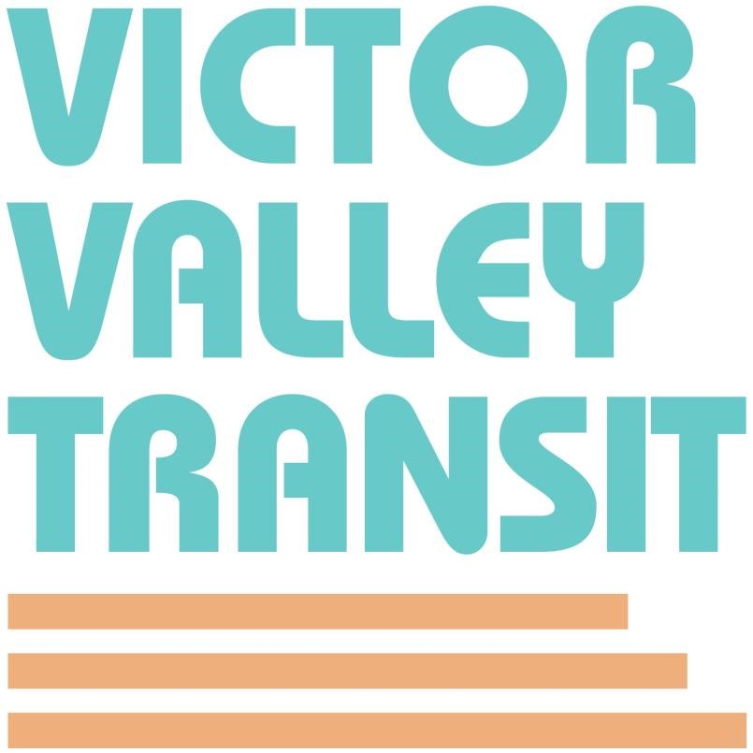

Social Media Channels

Like, follow, share, join, engage! The Victor Valley is our home, and we are committed to building a better future together. Join us as we share the journey.

Like us on Facebook
https://www.facebook.com/Officialvvta/
Follow us on Instagram
https://www.instagram.com/vvtransit/
Follow us on Twitter
https://twitter.com/VVTransit
Connect with us on LinkedIn
https://www.linkedin.com/in/vvta/
Follow us on TikTok
https://www.tiktok.com/@vvtransit/
Subscribe on YouTube
https://www.youtube.com/@vvtamarketing4775

A. VVTA SOCIAL MEDIA BEST PRACTICES

The Victor Valley Transit Authority (“VVTA”) is both the transit authority and the transportation-planning agency for the High Desert region of San Bernardino County and hereby sets forth the following best practices, procedures and disclaimers for its use of social media. “Social Media” is defined as any web-based platform hosted by a third-party that enable users to participate in social networking.

VVTA considers Social Media to be an invaluable tool to facilitate communication and transparency with the public. VVTA utilizes Social Media, including, but not limited to, Facebook, Twitter, Instagram, YouTube, and Linked-In to keep the public up-to-date on the latest news and learn more about VVTA. YouTube is also used to host recordings of VVTA meetings, and VVTA’s Facebook, Instagram and Twitter feeds are intended to keep transit-passengers and the public informed of travel impacts through our system, plus additional news, information, and entertainment.

DISCLAIMER

Communications made to VVTA using a Social Media channel or page will in no way constitute a legal or official notice or comment to VVTA for any purpose unless noted that comments will be part of a public record. VVTA cannot attest to the accuracy of all the information provided by third-parties or any other linked sites. VVTA does not endorse any comments or images posted on VVTA’s Social Media pages and such comments or images do not necessarily represent the views of VVTA.

OVERSIGHT

VVTA’s Social Media pages are intended for news, information, and entertainment purposes only. VVTA monitors its Social Media accounts Monday – Sunday from 8:00 a.m. until 5:00 p.m. and will respond to inquiries in a timely manner. Please note, responses may be delayed Friday – Sunday, on holidays, and after normal business hours. However, all service-related questions should be directed to VVTA customer service at 1-760-948-3030. Complaints should be directed to 1-760-948-4021, ext. 140. Your questions/concerns may also be answered by emailing info@vvta.org

CODE OF CONDUCT

VVTA appreciates your comments, ideas, and concerns and encourages respectful discourse. To best serve the public, the following code of conduct provides guidelines on how to best interact with VVTA’s Social Media pages. VVTA does not discriminate against any viewpoint but reserves the right to remove comments and block individuals that violate this Code of Conduct.
VVTA considers the following comments unacceptable:
- Vulgar, offensive, defamatory, or harassing language.
- Personal attacks or offensive terms that target specific individuals or groups.
- Comments that incite violence or illegal activity.
- Comments that promote, endorse, or oppose a service or product, political party, person campaigning for elected office or ballot proposition.
- Promotion of goods or services.

PRIVACY

VVTA’s privacy policies do not apply to VVTA’s Social Media channels and pages because those channels and pages are not hosted by VVTA. By accessing or using VVTA Social Media channels or pages, you are accepting the practices described in the hosting platform’s privacy policy.

CONTACT

If you have an issue or concern, please contact Victor Valley Transit through the following channels.
Online: http://vvta.org/wp-content/uploads/2018/08/VVTA-Complaint-Form.pdf
Phone: (760) 948-4021, ext. 140
Email: info@vvta.org

###

