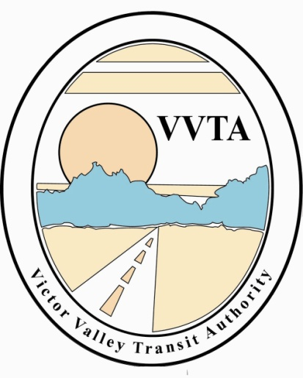

Victor Valley Transit Authority

CANCELED MEETING NOTICE

The Technical Advisory Committee meeting scheduled for December 7, 2022, at VVTA Offices at 17150 Smoke Tree Street, Hesperia at 3:00 pm has been cancelled due to the holidays.

The next scheduled meeting date will be
January 4, 2023, at 3:00 pm in person.

