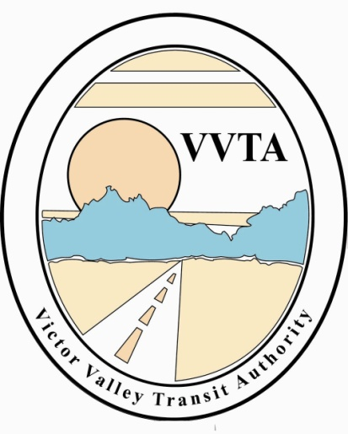

Victor Valley Transit Authority

CANCELED MEETING NOTICE

The Victor Valley Transit Authority Board of Directors meeting scheduled for December 19, 2022, at 9:30 am at Victor Valley Transit Authority, 17150 Smoke Tree Street, Hesperia, CA has been cancelled.

The next meeting will take place on
Tuesday, January 17, 2023, at 9:30 am at
Victor Valley Transit Authority, 17150 Smoke Tree Street, Hesperia, CA.

