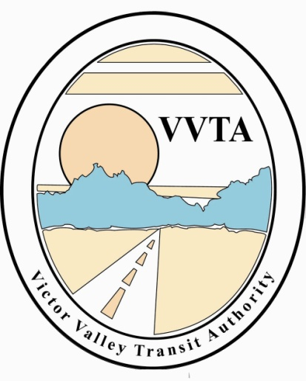

Victor Valley Transit Authority

CANCELED MEETING NOTICE

The Technical Advisory Committee meeting scheduled for February 5, 2020 at VVTA Offices at 17150 Smoke Tree Street, Hesperia at 3:00 pm has been cancelled.

The next meeting date will be March 4, 2020 at 3:00 pm at the Victor Valley Transit Authority, located at 17150 Smoke Tree Street, Hesperia, CA.

